BABU BANARASI DAS UNIVERSITY

2026-2027

SCHOOL OF COMPUTER APPLICATIONS
No SQL project On

Student Management System using MongoDB

Submitted to:  Mr Harendra Singh  Department: BCA(DS & AI)  Date: 25th September | Submitted by:  Dev kumar  Roll no: 20  Section: BCADS23

ACKNOWLEDGEMENT
I sincerely express my gratitude to my teacher Mr. Harendra Singh for giving me the opportunity to work on this NoSQL project titled “Student Management System Using MongoDB.”
This project helped me understand the basic concepts of NoSQL databases and learn MongoDB operations such as creating, retrieving, updating, sorting and deleting data.
I am thankful to my teacher for the guidance and support provided throughout the completion of this project.

INTRODUCTION
MongoDB is a popular NoSQL database management system that stores data in the form of documents. Unlike traditional relational databases, MongoDB does not require data to be stored in fixed rows and columns.
In this project, a Student Management System has been created using MongoDB. The database contains student information such as roll number, name, age, marks and city.
Different MongoDB operations have been performed on the student data, including inserting, displaying, updating, deleting, sorting, counting and searching records.

OBJECTIVES
- To understand the concept of NoSQL databases.
- To learn the basic features of MongoDB.
- To create a database and collection.
- To insert student records.
- To perform CRUD operations.
- To use comparison and logical operators.
- To perform sorting and filtering.

1. Create database
- Create or switches to the Student database.

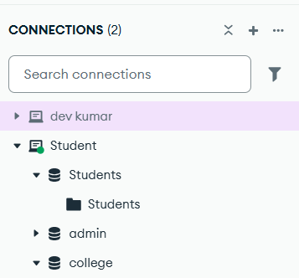

2. Create Collection
- Creates a collection named Students.
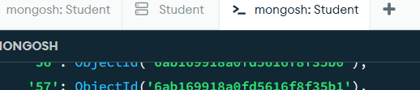

3. Insert 60 Students
- Insert student records into the collection.

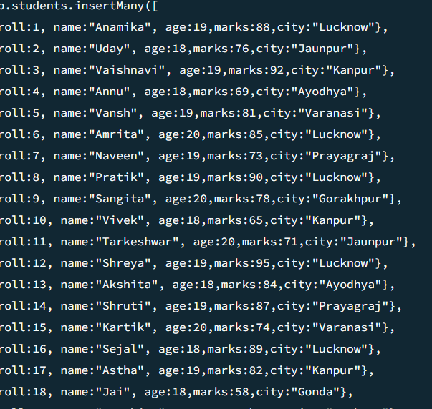

4. Display All Students
- Displays all student records.

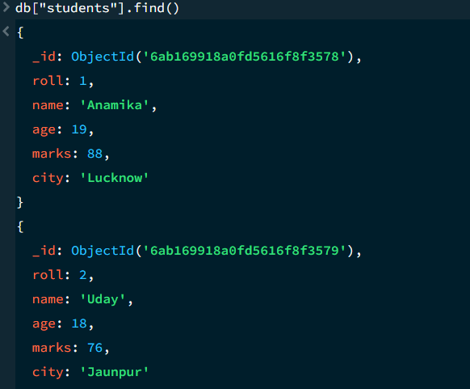

5.Equal to $eq
- Finds Students having exactly 88 marks.
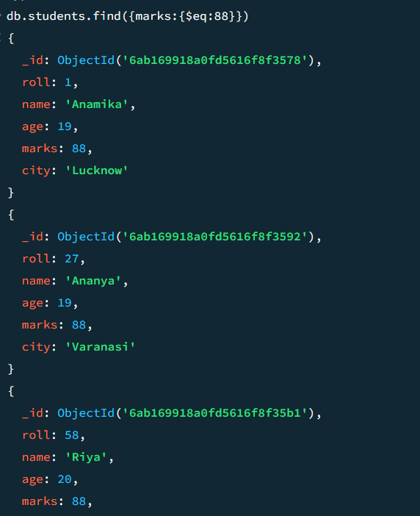

Greater Than $gt
- Finds Students scoring more than 85 marks.

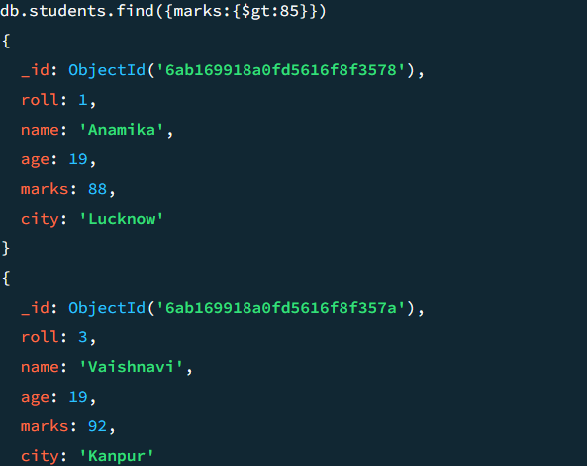

7.Less than $lt
- Finds Students scoring less than 60 marks
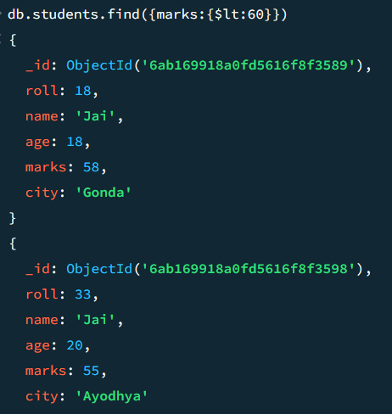

8. Greater Than or Equal $gte
- Finds Students with 90 or more marks.
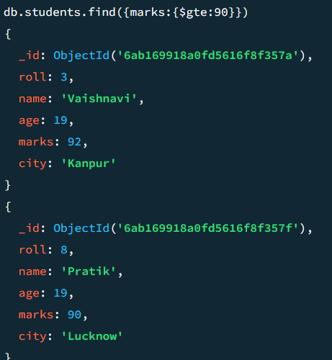

9. Less Than or equal $lte
- Finds Students with 70 or fewer marks.
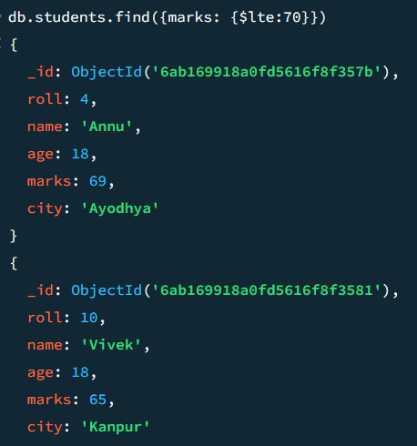

10. Update Student
- update the marks of the student with roll number 5.
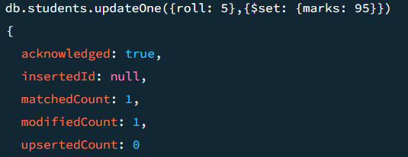

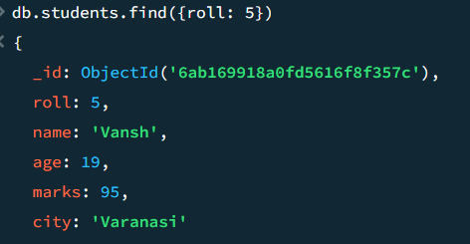

11. Delete One Student
- Deletes the student with roll number 10.
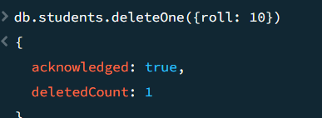

12. Delete Multiple Students
- Delete all Students having marks below 60.
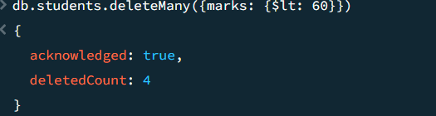

13 And Operator
- Finds students who are 19 years old and have more than 80 marks.
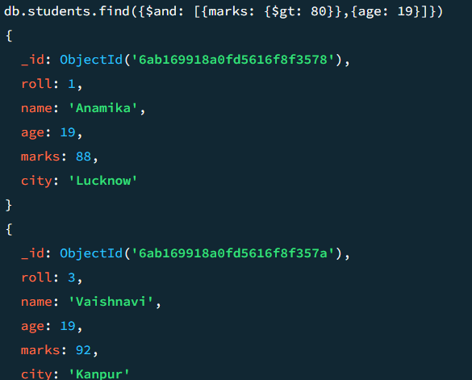

14. OR Operator
- Finds students from Lucknow or Kanpur.
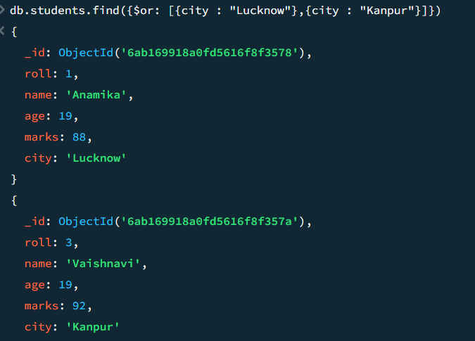

15. Sort Ascending
- Sorts students by marks in ascending order
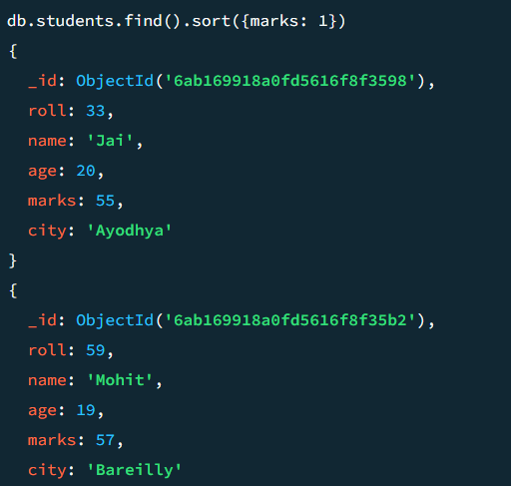

16. Sort Descending
- Sorts students by marks in descending order.
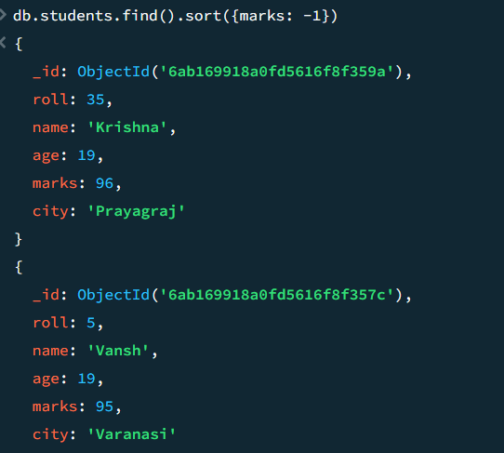

17. Limit Records
- Displays only the first 5 student records.
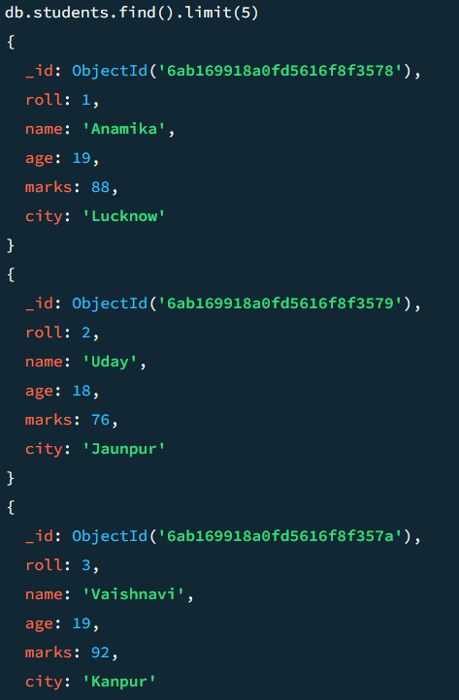

18. Search by City
- Finds all students from Lucknow.
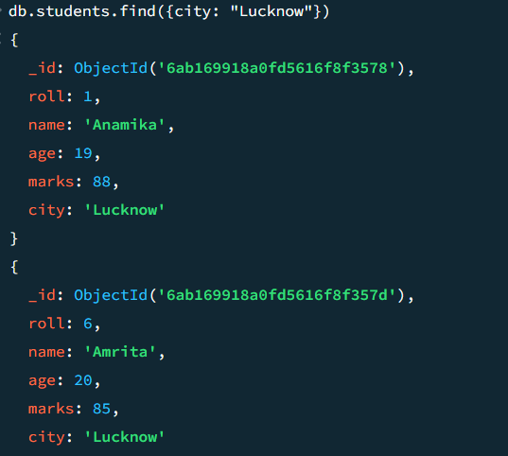

19. Count Students
- Counts the total number of student.

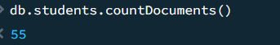

CONCLUSION
MongoDB was successfully used to create and manage a Student Management System. Various operations such as insertion, searching, updating, deleting, sorting, counting, and filtering were performed successfully.

LEARNING OUTCOME
- Learned the basic concepts of NoSQL and MongoDB.
- Learned how to create databases and collections.
- Practiced CRUD operations.
- Learned comparison, logical, sorting, and filtering operators.

RESULT
The Student Management System was successfully implemented using MongoDB, and the required database operations were performed successfully.

